# Question

Given an integer rowIndex, return the rowIndexth row of the Pascal's triangle.

Notice that the row index starts from **0**.

<https://upload.wikimedia.org/wikipedia/commons/0/0d/PascalTriangleAnimated2.gif>

In Pascal's triangle, each number is the sum of the two numbers directly above it.

**Follow up:**

Could you optimize your algorithm to use only *O*(*k*) extra space?

**Example 1:**

**Input:** rowIndex = 3

**Output:** [1,3,3,1]

**Example 2:**

**Input:** rowIndex = 0

**Output:** [1]

**Example 3:**

**Input:** rowIndex = 1

**Output:** [1,1]

**Constraints:**

* 0 <= rowIndex <= 33

# Solution

#### **Approach 1: Brute Force Recursion**

**Intuition**

We'll utilize a nice little property of Pascal's Triangle (given in the problem description):

<https://upload.wikimedia.org/wikipedia/commons/0/0d/PascalTriangleAnimated2.gif>

In Pascal's triangle, each number is the sum of the two numbers directly above it.

[Approach 4](https://leetcode.com/problems/pascals-triangle-ii/solution/#approach-4-math-specifically-combinatorics) will expand more on why it is so.

**Algorithm**

Let's say we had a function getNum(rowIndex, colIndex), which gave us the colIndexth number in the rowIndexth row, we could simply build the k^{th}*kth* row by repeatedly calling getNum(...) for columns 00 to k*k*.

We can formulate our intuition into the following recursion:

getNum(rowIndex, colIndex) = getNum(rowIndex-1, colIndex-1) + getNum(rowIndex-1, colIndex)

The recursion ends in some known base cases:

1. The first row is just a single 11, i.e. getNum(0, ...) = 1
2. The first and last number of each row is 11, i.e. getNum(k, 0) = getNum(k, k) = 1

|  |
| --- |
| class Solution {  private int getNum(int row, int col) {  if (row == 0 || col == 0 || row == col) {  return 1;  }  return getNum(row - 1, col - 1) + getNum(row - 1, col);  }  public List<Integer> getRow(int rowIndex) {  List<Integer> ans = new ArrayList<>();  for (int i = 0; i <= rowIndex; i++) {  ans.add(getNum(rowIndex, i));  }  return ans;  }  } |

**Complexity Analysis**

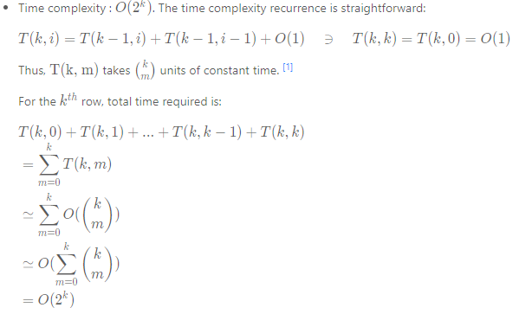

* Space complexity : O(k) + O(k) \simeq O(k)*O*(*k*)+*O*(*k*)≃*O*(*k*).
  + We need O(k)*O*(*k*) space to store the output of the k^{th}*kth* row.
  + At worst, the recursive call stack has a maximum of k*k* calls in memory, each call taking constant space. That's O(k)*O*(*k*) worst case recursive call stack space.

#### **Approach 2: Dynamic Programming**

**Intuition**

In the previous approach, we end up making the same recursive calls repeatedly.

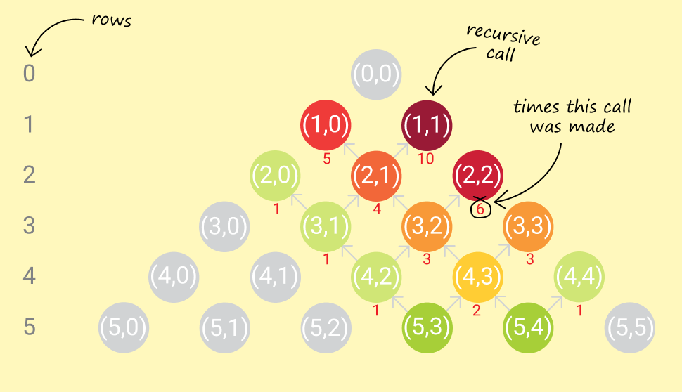

For example, to calculate getNum(5, 3) and getNum(5, 4), we end up calling getNum(3, 2) thrice. To generate, the entire fifth row (0-based row indexing), we'd have to call getNum(3, 2) four times.

It makes sense to store the results of intermediate recursive calls for later use.

**Algorithm**

Simple memoization caches results of deep recursive calls and provides significant savings on runtime.

|  |
| --- |
| class Solution {  private final class RowCol {  private int row, col;  public RowCol(int row, int col) {  this.row = row;  this.col = col;  }  @Override  public int hashCode() {  int result = (int) (row ^ (row >>> 32));  return (result << 5) - 1 + (int) (col ^ (col >>> 32)); // 31 * result == (result << 5) - 1  }  @Override  public boolean equals(Object o) {  if (this == o) return true;  if (o == null) return false;  if (this.getClass() != o.getClass()) return false;  RowCol rowCol = (RowCol) o;  return row == rowCol.row && col == rowCol.col;  }  }  private Map<RowCol, Integer> cache = new HashMap<>();  private int getNum(int row, int col) {  RowCol rowCol = new RowCol(row, col);  if (cache.containsKey(rowCol)) {  return cache.get(rowCol);  }  int computedVal =  (row == 0 || col == 0 || row == col) ? 1 : getNum(row - 1, col - 1) + getNum(row - 1, col);  cache.put(rowCol, computedVal);  return computedVal;  }  public List<Integer> getRow(int rowIndex) {  List<Integer> ans = new ArrayList<>();  for (int i = 0; i <= rowIndex; i++) {  ans.add(getNum(rowIndex, i));  }  return ans;  }  } |

But, it is worth noting that generating a number for a particular row requires only two numbers from the previous row. Consequently, generating a row only requires numbers from the previous row.

Thus, we could reduce our memory footprint by only keeping the latest row generated, and use that to generate a new row.

|  |
| --- |
| class Solution {  public List<Integer> getRow(int rowIndex) {  List<Integer> curr,  prev =  new ArrayList<>() {  {  add(1);  }  };  for (int i = 1; i <= rowIndex; i++) {  curr =  new ArrayList<>(i + 1) {  {  add(1);  }  };  for (int j = 1; j < i; j++) {  curr.add(prev.get(j - 1) + prev.get(j));  }  curr.add(1);  prev = curr;  }  return prev;  }  } |

The std::move() operator on vectors in C++ is an O(1)*O*(1) operation. [[2]](https://leetcode.com/problems/pascals-triangle-ii/solution/#fn2)

**Complexity Analysis**

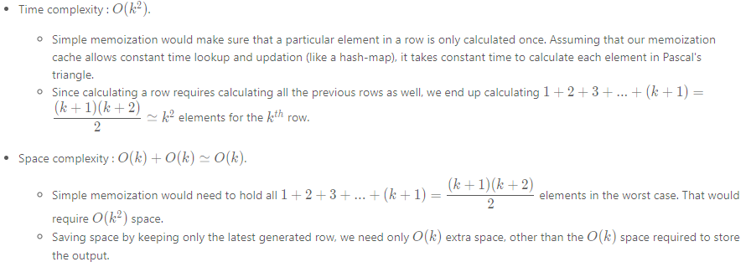

#### **Approach 3: Memory-efficient Dynamic Programming**

**Intuition**

Notice that in the previous approach, we have maintained the previous row in memory on the premise that we need terms from it to build the current row. This is true, but not wholly.

What we actually need, to generate a term in the current row, is just the two terms above it (present in the previous row).

Formally, in memory,

pascal[i][j] = pascal[i-1][j-1] + pascal[i-1][j]

where pascal[i][j] is the number in ith row and jth column of Pascal's triangle.

So, trying to compute pascal[i][j], only the memory regions of pascal[i-1][j-1] and pascal[i-1][j] are required to be accessed.

**Algorithm**

Let's take a step back and analyze the circumstances under which pascal[i][j] might be accessed. Given that we have already employed DP to save us valuable run-time, the access pattern for pascal[i][j] looks a bit like this:

* WRITE pascal[i][j] (after generating it from pascal[i-1][j-1] and pascal[i-1][j])
* READ pascal[i][j] to generate pascal[i+1][j]
* READ pascal[i][j] to generate pascal[i+1][j+1]

That's it! Once we've written out pascal[i][j]:

1. We don't ever need to modify it.
2. It's only read a fixed number of times, i.e. **twice** (thanks to DP).

Hypothetically, if we kept the the current row (in the process of being generated) and the previous row, in the same memory block, what kind of access patterns would we see (assume pascal[j] means the jth number in a row)?

* pascal[j] was somehow generated in a previous instance. Currently, it holds the previous row value.
* pascal[j] (which holds the jth number of the previous row) must be read when writing out pascal[j] (the jth number of the current row).
  + Obviously they are the same memory location, so a conflict exists: the previous row value of pascal[j] will be lost after the write-out.
  + Is that ok? If we don't need to read the previous row value of pascal[j] anymore, is there any harm in writing out the current row value in its place?
* pascal[j] (which holds the jth number of the previous row) must be read when writing out pascal[j+1] (the j+1th number of the current row). These are two different memory locations, so there is no conflict.

If we managed to keep all read accesses on the previous row value of pascal[j], **before** any write access to pascal[j] for the current row value, we should be good! That's possible by evaluating each row from the end, instead of the beginning. Thus, a new row value of pascal[j+1] must be generated before doing so for pascal[j].

The following animation demonstrates the above algorithm, used to generate the 4th row of Pascal's Triangle, from an existing 3rd row:

1 / 8

|  |
| --- |
| **class Solution {**  **public List<Integer> getRow(int rowIndex) {**  **List<Integer> row =**  **new ArrayList<>(rowIndex + 1) {**  **{**  **add(1);**  **}**  **};**  **for (int i = 0; i < rowIndex; i++) {**  **for (int j = i; j > 0; j--) {**  **row.set(j, row.get(j) + row.get(j - 1));**  **}**  **row.add(1);**  **}**  **return row;**  **}**  **}** |

**Complexity Analysis**

* Time complexity : O(k^2)*O*(*k*2). Same as the previous dynamic programming approach.
* Space complexity : O(k)*O*(*k*). No extra space is used other than that required to hold the output.
* Although there is no savings in theoretical computational complexity, in practice there are some minor wins:
  + We have one vector/array instead of two. So memory consumption is roughly half.
  + No time wasted in swapping references to vectors for previous and current row.
  + Locality of reference shines through here. Since every read is for consecutive memory locations in the array/vector, we get a performance boost.

#### **Approach 4: Math! (specifically, Combinatorics)**

**Intuition**

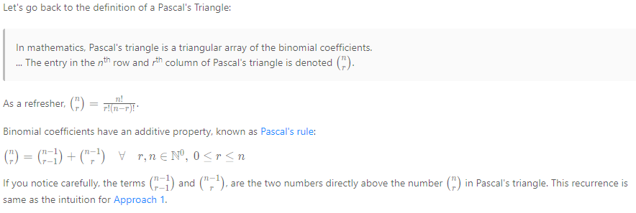

**Algorithm**

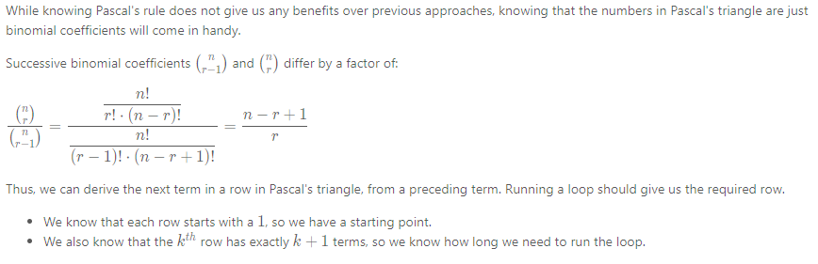

|  |
| --- |
| class Solution {  public List<Integer> getRow(int n) {  List<Integer> row =  new ArrayList<>() {  {  add(1);  }  };  for (int k = 1; k <= n; k++) {  row.add((int) ((row.get(row.size() - 1) * (long) (n - k + 1)) / k));  }  return row;  }  } |

**Complexity Analysis**

* Time complexity : O(k)*O*(*k*). Each term is calculated once, in constant time.
* Space complexity : O(k)*O*(*k*). No extra space required other than that required to hold the output.

#### **Further Thoughts**

* The symmetry of a row in Pascal's triangle allows us to get away with computing just half of each row.

Pop Quiz: Are there any computational complexity benefits of doing this?

Pop Quiz: Can you prove why these rows are symmetrical?

1. This [Stack Overflow answer](https://stackoverflow.com/a/26229383/2844164) has a good explanation. See the parallel between the time complexity recurrence and [Pascal's rule](https://en.wikipedia.org/wiki/Pascal%27s_rule). [↩︎](https://leetcode.com/problems/pascals-triangle-ii/solution/#fnref1)
2. Starting C++11, std:move() can be used to move resources across arguments or references. Since underlying representations are simply moved, and not copied, this can be a very efficient operation to transfer elements across collections or containers. See this [Stack Overflow answer](https://stackoverflow.com/a/12613436/2844164) for more. [↩︎](https://leetcode.com/problems/pascals-triangle-ii/solution/#fnref2)